**Hand Book**

**Generative AI**

**Disclaimer: The content is curated from online/offline resources and used for educational purpose only**

**Table of Contents**

Learning Outcomes iii

Chapter 8: Introduction to Generative AI 4

8.1 Introduction 4

8.2 Generative Models 6

8.3 Basics of Prompt Engineering 9

8.4 Large Language Models (LLMs) 11

8.5 ComfyUI for Image Generation 14

References: 18

# Premium Vector | White abstract background in 3d paper style | Abstract backgrounds, Abstract, Geometric backgroundLearning Outcomes

After completing this handbook, learner will be able to

Chapter 8: Introduction to Generative AI

|  |
| --- |
| **Learning Outcomes:**  By the end of this chapter, students will be able to:   * Understand how generative models produce new data samples and apply a model to generate similar outputs. * Remember the concept of prompt engineering and analyze effective prompt strategies for optimized outputs. * Describe the structure of LLMs in language processing and evaluate their effectiveness in text generation. * Apply ComfyUI to generate images from prompts and create customized visual outputs using specific style and content adjustments. |

# 8.1 Introduction

The new advancement in artificial intelligence has produced cutting-edge technologies that no longer just process information but also generate completely novel content. Such innovations have made generative AI a forceful arena and changed industries from art and entertainment to healthcare and business.

## 8.1.1 What is Generative AI?

Generative AI refers to a class of AI that can generate new, novel content based on patterns they have learned from existing data. In contrast to regular AI, which is used for the most part toward classification or predictive tasks, generative AI is in charge of creating something new —and it does not matter what: generating images, creating text, music, and even video. This is not content mimicry, but creation, with possible novel outputs that may come to look similar to or an improvement upon the original.

At its core, generative AI relies on models and algorithms that learn and understand patterns and structures from vast datasets. The two most important architectures applied in generative AI are GANs and Transformers.

Two of the best-known examples of generative AI are: Text-to-image models, which turn a description in text into lifelike images, and large language models that generate human-like text following an input prompt. All of this is already changing the business landscape by enabling rapid content creation, personalized user interactions, and even new forms of art and design.

## 8.1.2 Traditional AI vs. Generative AI: What is the Difference?

Generative AI constitutes a part of artificial intelligence, but it is remarkably different in its purposes and methods from traditional AI. Traditional AI is largely designed based on data analysis and classification and prediction. Traditional applications include spam filters and language translation and recognition capabilities, where accuracy is vital.

But for generative AI, things take on a different turn. Creativity and the generation of new content are the focuses. Where a traditional AI might say the picture is of a “cat” or “dog,” the generative AI would have a realistic drawing of the creature from scratch or perhaps even come up with something completely new, half cat and half dog. That difference makes clear what value generative AI adds to the table, particularly in areas where innovation and originality are of great importance.

**Table1: Traditional AI vs. Generative AI Difference**

|  |  |  |
| --- | --- | --- |
| **Aspect** | **Traditional AI** | **Generative AI** |
| **Primary Purpose** | Analyze, classify, and predict based on structured data | Create new content by learning from data patterns |
| **Common Uses** | Spam filtering, language translation, fraud detection | Image generation, content creation, audio synthesis, prototyping |
| **Focus** | Accuracy, reliability, and decision-making | Creativity, innovation, and originality |
| **Output** | Identifies or categorizes (e.g., labels an image as “cat” or “dog”) | Generates realistic or imaginative content (e.g., creates an image of a “cat-dog” hybrid) |
| **Value Addition** | Supports data-driven decisions and automation | Enables creative solutions and novel ideas |

# 8.2 Generative Models

One of the machine learning model classes that produces new samples of data like some input training set is the generative model. Unlike discriminative models, which focus on distinguishing between classes or predicting specific labels, generative models focus on understanding and recreating the data distribution itself. Therefore, these models are capable of generating realistic samples, and they play an important role in all sorts of data synthesis applications including image generation, text generation, and style transfer.

### Key Points:

* **Input**: A dataset is fed to train the model, for example, images of cats.
* **Output**: After training, it can generate new samples looking similar to the original data, for example, images of cats that have never existed in the training set.
* **Objective**: Learn the underlying data distribution and then be able to generate similar data.

## 8.2.1 Types of Generative Models

Generative models broadly can be classified based on the type of probabilistic approach they use:

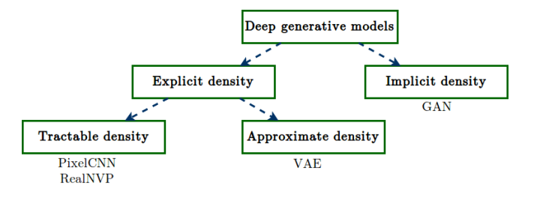

Source: <https://www.davidinouye.com/course/ece57000-fall-2020/lectures/gans.pdf>

### Explicit Density Models

These explicitly define a probability distribution over the data and often rest on statistical assumptions about the structure of the data. The following are some examples of explicit density models:

* **Variational Autoencoders:** VAEs approximate a probabilistic model of the data using a neural network, usually assuming a Gaussian distribution. They learn to encode input data into a compressed latent space and can generate new samples by decoding points from this space.
* **Autoregressive Models:** In these models, such as **PixelRNN** and **WaveNet**, data is generated one step at a time as a sequence. These models make an estimate of the conditional probability of each element in the sequence given all previous elements.

### Implicit Density Models

Implicit density models do not specify a probability density function directly but instead aim to learn to generate samples that are close to being realistic:

* **Generative Adversarial Networks (GANs):** GANs use two competing networks known as the generator and discriminator to produce realistic samples. The role of the generator is to generate apparently real fake data, while the discriminator's role is to be able to distinguish real and fake samples.
* **Energy-Based Models (EBMs):** Instead of defining directly a probability distribution, a function is defined that assigns lower energy to the real samples and higher energy to the fake ones.

## 8.2.2 Applications of Generative Models

Generative models have completely changed the way we work with, transform, and generate data.

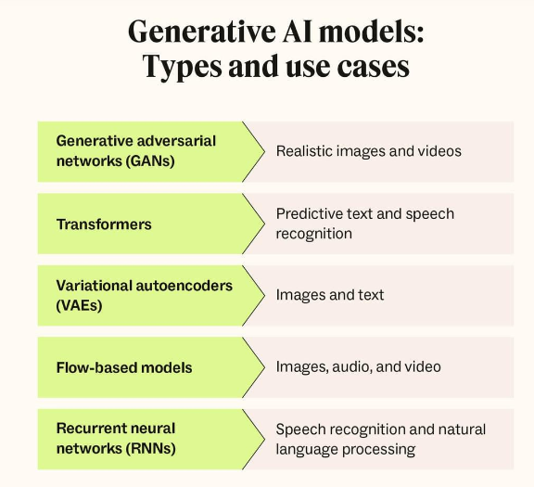

https://www.zendesk.com/dk/blog/generative-ai-guide/

**Here are the most important application areas**:

#### Image Generation and Editing

* Generative models can now create high-quality images starting from scratch. Parts of the creative process can be automated by artists and designers.
* Examples: AI-generated art, StyleGAN-generated faces, and deepfake technology.

#### Text Generation and Translation

* These text generative models, for example, GPT, produce text that sounds as if it is written by a human. They used for applications such as chatbots, content generation, and translation.
* Examples: ChatGPT, DALL-E's captioning, and OpenAI Codex for programming.

#### Data Augmentation

* Generative models can be used to augment training datasets by generating new samples, which come in handy when there is limited data. For example, GANs can be used to create variations of existing images for training computer vision models.

#### Drugs Discovery and Healthcare

* In drug discovery, generative models can be used to generate novel molecular structures or design proteins with specific properties, accelerating research and development in healthcare.

#### Other Creative Applications

* Music composition, the development of video game character, virtual worlds, and animation are other fields that leverage generative models to create immersive and unique content.

**Examples**:

* **StyleGAN2**: A model capable of generating ultra-realistic human faces that don’t exist.
* **OpenAI’s DALL-E**: Generates images based on textual descriptions, opening new avenues for art and design.
* **GPT-3**: A language model that can generate coherent and contextually accurate text for a wide range of applications, from chatbots to writing assistants.

## 8.2.3 Challenges and Considerations

While generative models hold immense potential, they also come with challenges and ethical considerations:

### Technical Challenges

* **Training Instability:** GANs particularly are known to suffer from instability in training due to the adversarial nature, which creates mode collapse and gradient vanishing problems.
* **Computational Complexity:** Generative models often require large computational powers, especially for training over large data or generating quality images or text.
* **Evaluation Metrics:** It is extremely challenging to evaluate the quality of the generated data. Standard metrics such as accuracy do not apply. Specialized metrics such as Inception Score (IS) or Frechet Inception Distance (FID) are used.

### Ethical and Social Considerations

* **Misuse and Privacy Risks:** Generative models can create deepfakes or unauthorized realistic content, which raises concerns about privacy and misuse.
* **Bias in Generated Content:** If trained on biased data, generative models can reproduce and even amplify those biases to lead to unfair or discriminatory outputs.
* **Intellectual Property:** Ownership of AI-generated content is still a matter of debate. Questions on copyright, authorship, and responsibility are very pertinent, especially when these models are used for commercial purposes.

### Environmental Impact

* The computational power required in training large generative models, however, has serious implications in terms of energy; therefore, sustainable practices include model optimization and efficient training.

# 8.3 Basics of Prompt Engineering

Prompt engineering is the art and science of engineering effective inputs to guide generative models-from large language models like GPT to image generation models like DALL-E and Stable Diffusion. Given that these generative AI models learn their outputs from patterns, the quality and structure of the prompt are likely to have a strong impact on the accuracy, clarity, and relevance of the output. Prompt engineering is one of those emergent skills important particularly in any domains that require accuracy and context.

## 8.3.1 Why Prompt Engineering Matters

Engineering prompts well lead to extracting the best possible output from a generative model, which supports productivity and creativity.

* **Enhances Output Quality:** Well-structured prompts reduce ambiguity, helping the model produce responses that are relevant, accurate, and detailed. Thoughtful prompts can lead to more nuanced, context-appropriate outputs that need less editing or filtering.
* **Maximizes Model Capabilities:** Prompt engineering allows users to unlock advanced features and capabilities within the model. For example, a prompt designed with detailed context can help a model generate more sophisticated responses, make contextual associations, or interpret complex queries.
* **Reduces Post-Processing:** With carefully designed prompts, users can reduce the need for extensive rephrasing, corrections, or multiple attempts. This saves time, especially for applications where high-quality results are required quickly, such as in creative writing, coding, or research summaries.

## 8.3.2 Types of Prompts

Understanding the various types of prompts is necessary to steer a model towards the most appropriate response. Not every objective requires the same prompt, and prompts can vary from purely descriptive ones to more context-driven requests.

* **Descriptive Prompts:** These prompts are used whenever the expected output is a specific, detailed output. These are those that hold only precise information thereby allowing the model to narrow its attention onto a well-defined topic. For instance, if one asks for "A technical explanation of convolutional neural networks (CNNs)", then the model would have to yield a response with specific concentration towards CNNs than general issues on AI.
* **Instructional Prompts:** Instructional prompts instruct a model to attempt a task step-by-step. These can be useful when generating structured-type outputs; procedures and list-based are excellent examples. For example, " List the steps to train a neural network" is an ordered output aimed at helping the user move along steps that make up neural network training.
* **Contextual prompts:** Provide the additional background, framing, or setting to help the model produce responses that fall into a particular scenario or perspective. For example: "A doctor and a patient in conversation." This would provoke the model to create dialogue in the context of a medical consultation. Such contextual requests are especially helpful in creative, conversational, or role-playing scenarios wherein the context has a massive impact on the tone and structure of the output.

## 8.3.3 Best Practices for Effective Prompts

To harness the full potential of generative models, it’s essential to follow best practices in prompt engineering. Here are key strategies to create effective prompts:

* **Be Specific:** Vague prompts lead to very general or irrelevant responses, while specific prompts push the model closer to what you want. A vague prompt would be something as broad and general as "Write about AI," while a targeted prompt would look something like "Write a summary of AI applications in healthcare, focusing on diagnostic tools and treatment recommendations.".
* **Use Context:** Relevant background or contextual information aids the model in understanding the purpose or the target audience for the response. For instance, "Explain GANs in simple terms for a high school audience" cues the model to adjust the language level and tone.
* **Test and Refine:** Different words and phrases can best accomplish a given objective, and fine-tuning tiny details in the words or additional clarification may significantly impact output quality. Repeated iterations through refining the prompt could introduce slight elements that differentiate for better accuracy.
* **Guide the Model's Style and Tone:** If tone or format is a consideration, encourage the model to change its style. That is, "Describe the process of machine learning in a friendly and conversational tone" will prompt the model to write a response that is clear and engaging. This is useful for applications such as customer service response, educational content, or creative writing.

## 8.3.4 Examples of Prompt Engineering for Different Models

Prompt engineering differs depending on generative models due to functionalities and kinds of output generated.

### Text Generation (for example, GPT-4)

**Prompt:** "Write a professional email that explains why a project delivery was late because the case involved some unforeseen circumstances.".

**Expected Output:** A well-formatted polite e-mail stating the delay, maybe with reasons for the delay and apology. This prompt makes the model use formal language that is appropriate only for a business setting.

### Code Generation (e.g., Codex):

**Prompt:** " Write Python code to implement a function that reverses a list "

**Expected Output:** Clean working Python code for the given task, perhaps even with comments explaining the code. For this reason, clear specification of the given task will make the model generate code that might be brief without any unnecessary information.

### Image Generation (DALL-E, for example, or Stable Diffusion):

**Prompt:** "Create a futuristic skyline at sunset with flying cars and neon lights.".

**Expected Output:** Imagined future city scenario. The sun sets over neon lights, flying cars. Descriptive adjectives such as sunset and neon lights detail the aesthetic and ambiance of the output.

Thus, prompt engineering is an essential method through which humans can get quality output from generative AI models. Through crafting, such users can improve the relevance, accuracy, and creativity of model responses. Specific, well-structured, and context-aware prompts will make the maximum performance of the model, reduce the need to post-process the output, and even make it possible to tailor the tone and style of output to meet different needs in text and code and image generation applications.

# 8.4 Large Language Models (LLMs)

Large Language Models (LLMs) like GPT-4, BERT, and PaLM represent the forefront of natural language processing (NLP) advancements, enabling machines to perform language-related tasks with impressive coherence, versatility, and sophistication. These models have unlocked new possibilities across domains by interpreting, generating, and analyzing human language with remarkable accuracy.

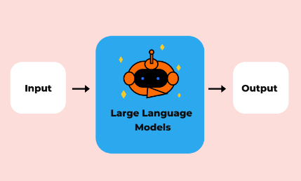

Source: https://skillcrush.com/blog/what-are-large-language-models-llms/

## 8.4.1 Definition and Functionality

* Large Language Models are neural networks trained on huge amounts of text data. They are built on Transformer architectures, which are especially good at sequential data and thus fit perfectly for language-related tasks.
* LLMs learn to generate human-like language by understanding complex patterns, contexts, and nuances within large datasets, enabling them to generalize and respond to various prompts accurately.

## 8.4.2 Training Data

Diverse corpora of books, websites, academic papers, articles, etc., covering many subjects and styles, form the datasets used to train LLMs. It is this diversity and amount of training data that allows such models to learn an enormous vocabulary and variety of topics, making them easily applicable to most language-related tasks from basic text generation to complex analyses such as summarizing a piece of writing, answering questions, even coding.

## 8.4.3 Applications of LLMs

Because LLMs can understand as well as generate human languages, they can be applied to a wide array of applications, such as:

* **Text Generation:** Generating coherent and contextually relevant text based on specific prompts.
* **Summarization:** Condensing information in articles, reports, or books to a concise summary.
* **Question Answering:** Responding accurately to questions by leveraging the context from the input text or learned knowledge.
* **Code Generation:** Writing, interpreting, and debugging code in programming tasks.
* **Language Translation:** Translate text across multiple languages in the main operation, maintaining contextual and semantic richness of the text.

## 8.4.4 Popular Large Language Models

There are various popular LLMs with different architectures, strengths, and application areas:

**GPT-4:** Developed by OpenAI, GPT-4 is known for its advanced text generation and nuanced understanding. It can perform multiple language-related tasks and excels in generating high-quality responses, adapting well to various contexts, and interpreting complex queries. GPT-4 is versatile, covering a range of applications from creative writing to technical support.

**BERT (Bidirectional Encoder Representations from Transformers):** Developed by Google, BERT is focused on natural language understanding (NLU). Due to its bidirectional architecture, BERT understands context by taking into consideration each word relative to other words in both forward and backward directions. Therefore, BERT is immensely successful for sentiment analysis, named entity recognition, and question answering tasks.

**PaLM (Pathways Language Model):** Google's PaLM is built to process complex language tasks with enhanced interpretability and efficiency. It is based on the Pathways system of Google, which utilizes the multi-tasking ability for better performance on a variety of tasks, such as reasoning and contextual understanding. Therefore, this model would be quite suitable for large-scale NLP applications where the need is for model explainability and task diversity.

## 8.4.5 Working with LLMs: Key Concepts

To effectively apply LLMs, there must be some fundamental knowledge about how they work and strategies about how best to use them.

### Tokenization

Tokenization is the process of breaking down text into smaller, manageable units called tokens, which can represent words, sub-words, or even individual characters. Tokenization enables the model to process and interpret text efficiently, as each token corresponds to an interpretable input. By analyzing tokens, LLMs can construct meaning and make predictions based on relationships between these tokens.

### Attention Mechanism

Attention is a core feature of Transformer architectures and allows LLMs to determine which parts of the input text are most relevant when generating an output. Through attention, the model assigns varying levels of importance to different tokens, helping it understand context and prioritize significant words or phrases. This mechanism enhances the model’s ability to interpret complex sentences and maintain coherence over longer texts.

### Fine-Tuning vs. Prompt Engineering

* **Fine-Tuning:** Fine-tuning involves training an existing pre-trained model on a new, specific dataset to customize it for particular tasks. For example, fine-tuning a model on medical literature allows it to generate more accurate outputs for healthcare-related queries.
* **Prompt Engineering:** This involves crafting input prompts to guide the model toward producing specific types of responses without modifying its internal parameters. By carefully structuring prompts, users can control the tone, format, and detail level of the model’s responses, making prompt engineering a versatile and non-invasive alternative to fine-tuning.

## 8.4.6 Examples of LLM Applications

LLMs have demonstrated exceptional versatility across various industries, providing solutions for diverse and complex tasks. Here are some notable applications:

### Customer Support

LLMs, in particular models of the type of GPT-based, are used to answer real-time queries and support needs related to customer support. As such, the ability of LLMs to integrate with chatbots or virtual assistants can offer answers to the most common questions, aid customers in troubleshooting steps, and provide recommendations that match the individual needs of a customer. Their ability to understand complex inquiries makes LLMs enable dealing with complex customer inquiries, thereby improving user experience at the same time as alleviating human agent overload.

### Content Creation

LLMs help in reducing the workload in content generation, irrespective of the formats involved-articles, blog posts, marketing materials, and product descriptions. It offers simple prompts to the user and delivers intelligible content that fits the tone and style necessary for the required work. This use is valuable especially for companies dealing with a large volume of content in industries like digital marketing, journalism, and e-commerce.

### Assistance in programming

These models, like Codex from OpenAI or Copilot by GitHub, are superbly fine-tuned for programming work by helping users generate code, debug and document. LLMs are able to interpret natural language prompts to generate snippets of code; suggest improvements with even explanations for code, making this feature highly useful for developers who often face repetitive code patterns or tasks that require accurate syntax while focusing on efficiency.

Large Language Models represent a significant advancement in NLP, enabling machines to generate, understand, and interpret language with human-like accuracy. Models like GPT-4, BERT, and PaLM each have unique strengths, and their applications span numerous fields, from customer service to programming. By understanding key concepts like tokenization, attention mechanisms, and prompt engineering, users can leverage LLMs to their full potential, optimizing them for specific tasks with minimal adjustments or customized fine-tuning. As LLMs continue to evolve, their role in automating language tasks, enhancing productivity, and assisting in creative endeavours is expected to grow further.

# 8.5 ComfyUI for Image Generation

ComfyUI is a user-friendly interface for building complex image generation workflows, designed primarily for models like Stable Diffusion. By offering an intuitive, visual approach to configuring and fine-tuning image generation, ComfyUI empowers users to craft detailed prompts, adjust parameters, and experiment with multiple settings, making it an accessible tool for both beginners and advanced users.

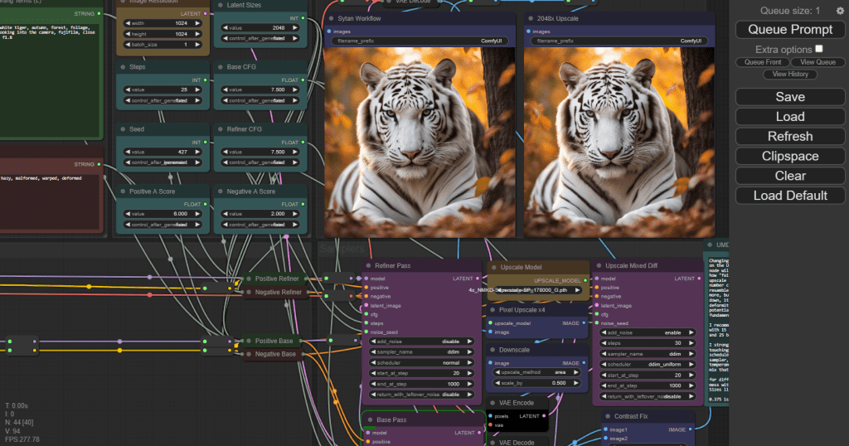

Fig: Comfy UI

## Introduction to ComfyUI

ComfyUI aims to make the task of image generation easy as a user can design and orchestrate workflows graphically instead of depending upon code or scripts to configure the many elements of an image generation pipeline, which may include model selection, prompt definition, and parameter settings. This more graphical way of configuration makes it easier to understand and control how to flow image generation experiments while also being precise.

## 8.5.1 Key Features of ComfyUI

* **Support for Generative Models**: ComfyUI integrates with popular image generation models like Stable Diffusion, as well as other models available on platforms like Hugging Face.
* **Customizable Settings:** Users can modify image settings, such as style, resolution, and detail, to create images that match their vision.
* **Modular Workflow Design:** ComfyUI organizes workflows into modular components, or “nodes,” which users connect to build custom image generation pipelines. Each node represents a specific stage or functionality in the process (e.g., prompt input, model selection, image output).

## 8.5.2 Setting Up ComfyUI: Online Web Version and Offline Version

ComfyUI offers two primary options for setup: an online web version accessible through the browser, and an offline version that users can install and run locally. Each setup type has its own advantages depending on user needs and hardware resources.

### Online Web Version

The online version of ComfyUI allows users to access the interface directly from a browser without requiring a full local installation of models and dependencies. This approach is convenient for users who want to start generating images quickly and may not have the hardware resources for extensive computations.

#### Steps to Access the Online Version:

* Access a Hosted ComfyUI Service: Some online platforms and third-party providers host ComfyUI on cloud servers, making it easy to access. Check if ComfyUI has an official or supported instance available via services such as Hugging Face Spaces, Google Colab, or other cloud-based platforms.
* Create or Log into an Account: If the service requires it, create an account or log in.
* Load Available Models: Online instances often provide pre-loaded models like Stable Diffusion or other diffusion models, so users can get started without managing model files themselves.
* Set Model Preferences: Choose the specific model version or configuration available on the hosted server, if options are provided.
* Begin Using the Interface: Start creating workflows, prompts, and adjusting parameters directly in the web interface.

#### Benefits of the Online Version:

* Quick Access and Setup: No installation or hardware configuration is required.
* Cloud-based Computation: Image generation is managed by cloud resources, reducing the load on your local machine.
* Available Anywhere: Accessible from any device with internet access and a browser.

#### Limitations of the Online Version:

* Dependence on Internet Connection: Requires a stable connection to function smoothly.
* Potential Usage Limits: Some platforms may impose quotas or limitations on the number of images generated.

### Setting up offline ComfyUI

Setting up offline ComfyUI requires an installation of Python and some image model-specific packages, such as those needed for Stable Diffusion or other preferred generative models.

#### Installation Steps

* Python and Dependencies: First, install Python (if not already installed) and use pip to install the required packages for ComfyUI and the relevant image generation models.
* Installing ComfyUI: ComfyUI itself can be installed from its GitHub repository or through package managers, depending on the source.
* Setting up Model Files: Download any necessary pre-trained models, like Stable Diffusion or other diffusion models from repositories such as Hugging Face or model-specific directories. These models will be loaded into ComfyUI for image generation.

#### Launching ComfyUI

Once installed, ComfyUI can be launched as a graphical interface. The user can access the interface via a web browser or directly on a local machine, where a window with the drag-and-drop interface will appear.

#### Connecting to Pre-trained Models

ComfyUI is designed to work seamlessly with pre-trained models from sources like Hugging Face. Users can select models from the list of available ones, load custom models, or specify paths to local model files, providing flexibility in model selection and configuration.

## 8.5.3 Creating an Image Workflow in ComfyUI

In ComfyUI, workflows are constructed by connecting nodes, where each node represents a distinct part of the image generation process. This modular approach allows users to control the pipeline in stages, from selecting a model to adjusting parameters, crafting prompts, and finally viewing the generated image.

### Example Workflow for Image Generation

* Load a Pre-trained Model Node: The process begins by selecting a model node that loads a model, such as Stable Diffusion, for realistic image generation. The model node can be linked to various models based on the task and desired output style.
* Add a Prompt Node: Here, the user enters a descriptive prompt that directs the model’s image generation. For example, “A tranquil forest at dawn with soft mist and sunlight filtering through trees.”
* Adjust Parameters Node: This node allows users to modify specific parameters, such as image resolution, style (realistic, abstract, etc.), and level of detail, to influence the final output. Each parameter can be adjusted to refine aspects of the image’s appearance.
* Generate and View Node: Once all settings and parameters are configured, this node executes the workflow to generate the image. The generated image can then be previewed directly within ComfyUI, allowing users to assess the initial output and determine if further adjustments are needed.

## 8.5.4 Tips for Effective Image Generation with ComfyUI

To maximize the quality and relevance of generated images, users can follow these strategies:

* Use Detailed Prompts: Incorporating specific details in prompts helps guide the model to generate more accurate images. For instance, include descriptive elements such as colors, atmosphere, and perspective (e.g., “a serene lake at sunset with orange and pink skies and reflections on the water surface”).
* Experiment with Styles: ComfyUI offers options to adjust the style, including realism, illustration, or abstract qualities. Trying out different styles can lead to varied visual aesthetics and help users find the most suitable representation.
* Iterate with Feedback: Image generation is often iterative. Reviewing generated images, refining prompts, and adjusting parameters can lead to significant improvements. This iterative feedback process is essential for producing high-quality, tailored images.

## 8.5.5 Advanced Features of ComfyUI

For advanced users, ComfyUI provides several powerful features to enhance image generation workflows:

### Batch Processing

Batch processing allows users to generate multiple images in one workflow by exploring prompt variations or changing model parameters across multiple runs. This feature is particularly useful for users who want to test different prompt phrasings or settings simultaneously to see which combination produces the best results.

### Inpainting and Masking

Inpainting is a feature that enables users to selectively alter specific areas of an image while preserving the rest of it. With masking, users can outline sections they want to change, which is useful for refining details or correcting parts of an image without regenerating it entirely. This feature is beneficial when fine-tuning specific sections in an otherwise satisfactory image.

### Post-Processing Nodes

After generating an image, post-processing nodes can adjust properties such as sharpness, brightness, and contrast directly within ComfyUI. This reduces the need for external editing tools, as users can enhance or refine the generated images within the workflow itself, saving time and maintaining consistency in image quality.

ComfyUI is a powerful yet user-friendly tool for image generation, particularly suited for models like Stable Diffusion. By offering a modular, drag-and-drop interface, ComfyUI simplifies building image workflows, making it accessible to users with various levels of expertise. Its flexible setup, support for detailed prompts, and range of advanced features—including batch processing, inpainting, and post-processing—enable users to experiment with and optimize their image generation results. Through intuitive control over image settings and iterative adjustments, ComfyUI helps users create high-quality, customized images that align closely with their creative vision.

# References:

* <https://www.weforum.org/agenda/2024/02/green-jobs-green-skills-growth/>
* [Generative AI: A comprehensive guide](https://www.zendesk.com/dk/blog/generative-ai-guide/)
* <https://www.davidinouye.com/course/ece57000-fall-2020/lectures/gans.pdf>
* <https://www.zendesk.com/dk/blog/generative-ai-guide/>
* <https://www.comfy.org/>
* <https://www.ibm.com/topics/large-language-models>
* https://www.techtarget.com/whatis/definition/large-language-model-LLM
* <https://www.ibm.com/topics/prompt-engineering>
* <https://platform.openai.com/docs/guides/prompt-engineering>
* <https://www.mckinsey.com/featured-insights/mckinsey-explainers/what-is-prompt-engineering>



**Disclaimer: The content is curated from online/offline resources and used for educational purpose only**